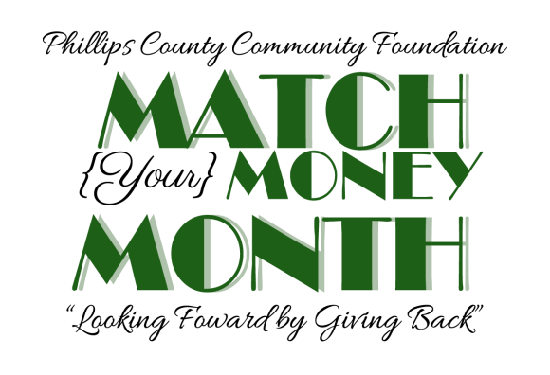
PERMISSION AND RELEASE TO USE MY IMAGE OR VOICE RECORDINGS

I, the undersigned, hereby grant Phillips County Community Foundation permission to use my image, likeness and sound of my voice as recorded on any medium, including but not limited to digital, audio or video tape; separately or in combination, or in any medium or format now known or invented in the future, without payment or any other consideration. I understand and agree that these images and recorded materials will become the property of Phillip County Community Foundation; that my image may be edited, copied, exhibited, published or distributed in connection with “The Amazing Race of Phillips County” without geographical limitation; and I waive the right to inspect or approve the finished product which includes my likeness.

By signing this Release, I acknowledge and agree to the terms herein to be effective from the date signed below until the copyright expiration date of the finished photographs and/or recordings as described above; and hereby release and forever discharge Phillips County Community Foundation from all claims, demands and causes of action which I, my heirs, representatives, executors, administrators or any other persons acting on my behalf or on behalf of my estate may have by reason of this Release or arising out of use of the materials covered by this Release.

____________________________________ ______________________
Signature Date

*If this Release is obtained from a person under the age of 18, the signature of that person’s parent or legal guardian is also required.

________________________________
Name of child

__________________________________ _____________________________________
Parent’s signature (Print name)

