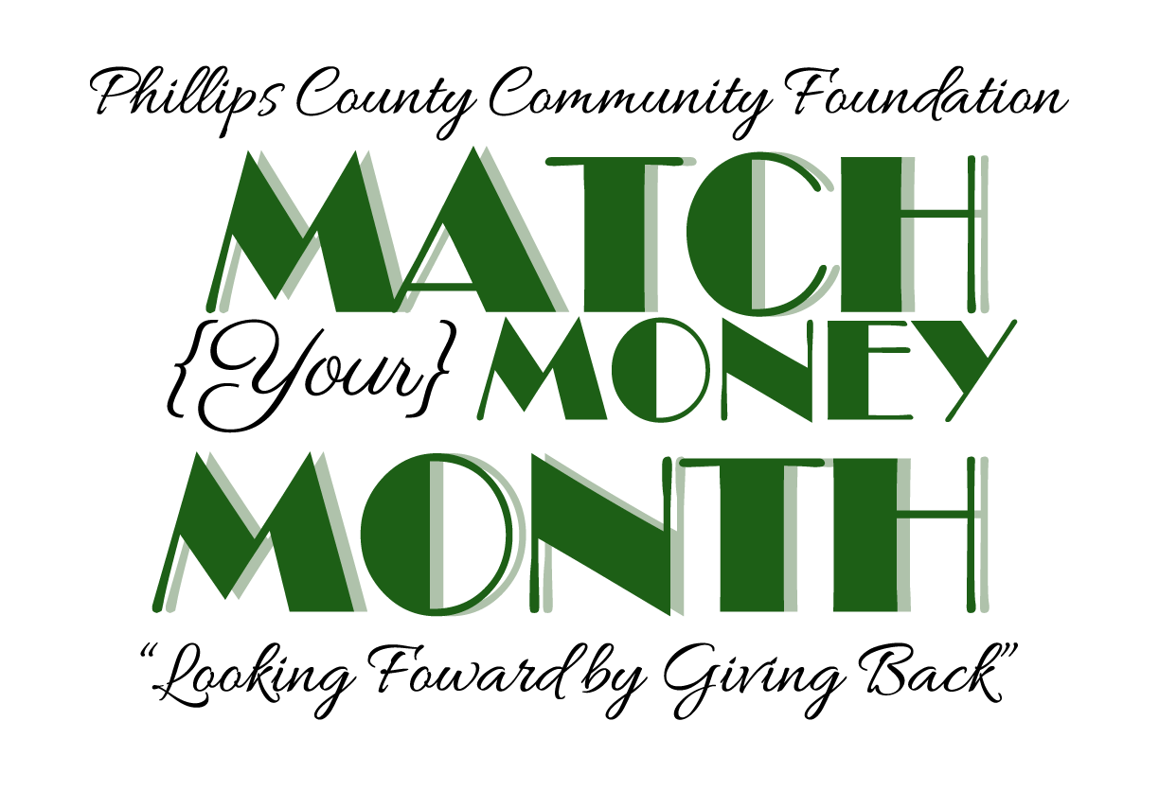
“The Amazing Race of Phillips County”
October 6, 2019
TEAM REGISTRATION FORM
Team Member Information
Name_____________________________________ Contact number _________________________
Address____________________________________ ________________
Team T-shirt size: S/M/L/XL Waiver and Release of Liability Form submitted _______

Name_____________________________________ Contact number _________________________
Address_____________________________________________________
Team T-shirt size: S/M/L/XL Waiver and Release of Liability Form submitted _______

Name_____________________________________ Contact number _________________________
Address_____________________________________________________
Team T-shirt size: S/M/L/XL Waiver and Release of Liability Form submitted _______

Name_____________________________________ Contact number _________________________
Address_____________________________________________________
Team T-shirt size: S/M/L/XL Waiver and Release of Liability Form submitted _______

Team Name: _________________________________________

Team Captain: ________________________________________

Team Sponsor: ________________________________________
Sponsor Contact: __________________________________ Contact Number _________________
Designated non-profit organization to receive the $500 cash prize if this team is the Race winner:
_______________________________________________

Note: No more than 2 team members may be between the ages of 12-18, and each of those must have parental consent to participate.
I further understand and voluntarily assume the risks and dangers inherent in participating in the Event and the Team. I understand that I am solely responsible for my health and safety, certify that I am physically capable of participating in the Team and the Event, and am unaware of any restrictions placed on me that would in any way prevent me from safely participating in the Event. I agree to abide by any decision of an event official relative to my ability to complete the Event safely and I further agree that Event officials or volunteers may recommend necessary emergency treatment for me. In the event that I should require medical care or treatment, I agree to be financially responsible for any costs incurred as a result of such treatment. I am aware and understand that I should carry my own health insurance.
The Sponsor of this Team has no responsibility for the event and does not assume any liability for the event due to sponsorship.
______________________________________ ________________________________________
Member signature Member signature
______________________________________ __________________________________________
Member signature Member signature

The Amazing Race of Phillips County is not affiliated with and does not represent the TV show “The Amazing Race”, which is owned by CBS. This is not a qualifying event for any other race.



